

Darshan restaurant

**Project Partners:**

PARI VAIBHAVPARI B, BCA-5TH

:: submitted to :: BKNM University, Junagadh

:: GUIDED BY ::

Mr. Ripal V. Pandya

Mr. Milind V. Anandpara

**A**

## PROJECT REPORT ON

**DARSHAN RESTAURANT**

# Submitted in Fulfillment of Requirements For Completion of Semester - 5 in Bachelor of computer application

**Year 2025 To**

**SHASHTRI SWAMI SHREE DHARMAJIVANDASJI INSTITUTE OF INFORMATION TECHNOLOGY**

**JUNAGADH**

**Guided By: Prepared By:**

**Mr. Ripal V Pandya Pari Vaibhavpari bhupatpari**

**Mr. Milind V Anandpara**

**PREFACE**

At Present of life of the global knowledge is must be required in every field. In present era the software industry is the most popular industry in world and the INDIA is one of the best and biggest development countries in software development. In INDIA there are many companies of computer software and hardware are dealing in international market and get a worldwide market and done the transaction throw the new internet technology.

And the other industries like multimedia, graphics, textile, automation, air & spacecraft, animation, telecommunication, education etc. are also dependence on the computer industries, and the transaction in follows industries are made in international market hear speed and accuracy is must be required and the only & only one medium gives a better accuracy and greatest speed that is internet technology.

In a present era, every human must have some kind of special knowledge in interested field. So, we choose the computer field and our specialization is on the internet technology because this is the fastest growing field in the world. And at present in most of fields uses the internet technology for data and information passing. There are many ways to send and receive data and information over internet like throw e-mail, website, videoconference etc. and present life not only industrial and big business organization uses the internet technology but also many educational institutes , small private organization, small bank and other people uses the internet technology for handling management of institute for advertising purpose for transaction purpose and online trading purpose present market is a grow up with a technology.

Here we focus on Social Network, where website is used to connect with friends and family using forums. One can discover new people and communities and get fresh news about competitive exams, educational institutes and top stories of nation. We can share our thoughts, suggestions and ideas all in one place.

The utility of computer in every field can hardly be our over emphasizing in the era of stiff competition and rapid industrialization. This essentially raises the need of most qualified in addition, skill manpower in the field of computer.

In the course of BCA designed by the “BKNM University” then have taken full care of this thing and designed the course in such a manner with which a student can get theoretical and practical both type knowledge perfectly. According to the rules of regulations of “BKNM University” in the course of BCA in fifty(5th) Semester we have a subject of Project Work, in which we have to create a website.

We have prepared a website of “darshan restaurant”. We have covered all necessary information about their institute and the concept of Website. We have tried as a best present this website report in such a way that it makes easy to understand the project work we have done for the “darshan restaurant”.

#### Pari Vaibhavpari b.

**ACKNOWLEDGEMENT**

We are very thankful to all whose have helped in preparing this project. We are feeling a great happiness to present this website project. First of all we would like to thank **“BKNM University”** who give me an opportunity to give a chance to prepare a project.

Before we get in to thick of the things we would to add a few heartfelt words for the people who were part of this project numerous ways, people who give unending support right from the stage project ideas was conceived. In particular we would like to thank **Ripal V Pandya, Milind V Anandpara (Project Guide)**, who has always inspired us and has directed us towards the successful completion of our project. They have been the guided through the project and their encouragement has left me indebted to them.

We are very thankful to the **Director Sadhu RushikeshdashjiSwami** and the **Asst. Director Mr. Rajesh Bharad** of **Shastri Swami Shree Dharmajivandasji Institute of Information Technology – Junagadh**.

Thank you…

**Date:** 04/10/2025 PARI VAIBHAVPARI B.

**Place:** Junagadh

**I N D E X**

|  |  |  |
| --- | --- | --- |
| **NO** | **Particulars** | **Page No** |
| 1 | Project Profile | 1 |
| 2 | Use of System Development Life Cycle Model | 2 |
| 3 | Feasibility Study | 5 |
| 4 | Requirement Gathering | 9 |
|  | **Requirement Analysis**   1. Hardware and Software Requirement 2. Front - End Tools 3. Back - End Tools 4. Other Tools & Technology Used | 10 |
| 5 | Project Abstracts (User Roles & Capabilities) | 11 |
| 6 | Proposed System | 12 |
| 7 | Advantages & Limitations of Proposed System | 13 |
| 8 | Evaluative Report Using Pert Chart and Gantt Chart | 14 |
| 9 | **Data Flow Diagram**   1. Context level 2. 1st Level 3. 2nd Level | 17 |
| 10 | Use Case Diagram | 26 |
| 11 | Flow Chart | 28 |
| 12 | Cost Estimation | 31 |
| 13 | Data Dictionary | 33 |
| 14 | Screen Layouts | 35 |
| 15 | Special Utilities | 55 |
| 16 | Testing | 56 |
| 17 | Implementation | 61 |
| 18 | Bibliography | 62 |

# PROJECT PROFILE

|  |  |
| --- | --- |
| **Project Title** | Darshan restaurant |
| **Project Description** | Darshan Restaurant is a dynamic and user-friendly web application designed to streamline food ordering, customer reviews, and restaurant management. Built with PHP and MySQL for backend functionality, styled using Bootstrap for responsive design, and enhanced with SweetAlert for interactive alerts and confirmations, this system offers a seamless experience for both customers and administrators. |
| **Front End** | PHP, HTML , CSS , JAVASCRIPT |
| **Back End** | MYSQL |
| **Other Tools** | Bootstrap, sweetalert |
| **Guide** | Mr. Ripal V Pandya, Mr. Milind V Anandpara |
| **Submitted To** | BKNM University, Junagadh(S.S.S.D.I.I.T Collage) |

**USE OF SYSTEM DEVELOPMENT LIFE CYCLEMODEL**

Software Development Life Cycle (SDLC) is a process for development of software. There are some steps to follow to create a software application.

In an SDLC the steps follow requirement gathering. In requirement gathering questionnaire, personal interview etc. are the method for gathering information. Analysis phase includes creating Software Requirement Specification and analyze the gathered data. In design phase, design of Software application i.e. database design and GUI design have to be prepared. In coding phase, coding is done of different modules and forms. In testing phase, the different type of testing is done like integration testing, unit testing, system testing and at last the created software is implemented and maintained.

Following are the different Life Cycle Model example.

* Waterfall model
* Iterative waterfall model
* Prototyping model
* Evolutionary model
* Spiral model
* R.A.D. model (Rapid Application Development)

# PROTOTYPE MODEL

In this project I have used the prototyping model because the prototyping model suggests that before development of the actual software, a working prototype of the system should be built first. A prototype is a like a bike or any vehicle implementation of a system usually exhibiting limited functional capabilities, low reliability, and inefficient performances of the model are developed first.

Another important use of the prototyping model is that it helps to critically examine the technical issues associated with the product the response time of a hardware controller, or the efficiency of a sorting algorithm etc. in such technical issues. The third reason for developing a prototype is that it is impossible to “get it right” the first time, and we must plan to throw away the first product in order to develop a good product.

The prototyping model of software development is shown below. The model starts with an initial requirement gathering phase. A quick design is carried out and the prototype model is built using several shortcuts. The shortcuts might involve using inefficient, inaccurate, or dummy functions.

This cycle continues until the user approach the prototype. The actual system is then developed using the classical waterfall approach. However, in this development effort, the requirements analysis and specification phase become redundant since the working prototype along with the user feedback servers as an animated requirements specification.

Here we use some software for creating the prototype model like MY SQL as a back-End, Visual Studio Code, HTML, DHTML, Figma ,PHP as a front-End tool.

**The diagram of Prototype Model:**



**Requirements**

**Gathering**

**Quick design**

**Requirement refine**

**Built a Prototype**

**Customer evaluation of prototype**

**Test**

**Implement**

**Design**

**Maintenance**

# FEASIBILITY STUDY

Feasibility of a project determines whether it is possible to developthe project. These are four main factores, which determine the feasibility of the project. They are discussed as follow.

The main aim of feasibility study is to determine whether developing the project is functionally and technically feasible or not.

The feasibility study involves analysis of the problem and collection of data which world be input to the system, the processing required to be carried out on these data, the output data required to be product by the system, as well as study of various constraint on the behavior of the system.

An initial determine in a proposal that whether an alternative system is feasible or not. To determine feasibility of candidate system in all respect I need to consider following feasibility factors:

There three types of feasibility study.

1. Technical
2. Operational
3. Economical

Technical feasibility considers whether the desired project can be completed the framework of available technology. As our project is developing the website, this is not much of problem because there are many advanced web editing tools are available.

Operational feasibility was done to that each models of mobile will come in future will be changed so the database will be changed of each mobile model. Therefore, the site should provide all functionality for a proper website. Since this website has the changeable resources by that we visit some informative website for the help to this website to satisfy the scope of the operational feasibility.

### Technical Feasibility :

The main aim of technical feasibility study is to detername whether it is possible to develop the proposed system with the present technologies available and study the technical requirements and their availability in the organization & the technical equipment availability in market.

So, in this project technical requirements is: -

### Hardware:

* 1. A Computer With
  2. 4 GB RAM
  3. 1 TB Hard Disk
  4. Intel Core Processor

### Software:

1. Visual Studio Code
2. Xampp

### Economical Feasibility :

The economic feasibly takes into consideration the financial matters regarding the proposed system. The organization measures the cost effectiveness of the proposed system. The economical feasibility of the proposed system is as under budget of a company or not! This is checked in economical feasibility.

* The Cost of development is approximant – 12000
* Domain cost’s – 0
* The design will a coadding to local and near to -2000
* Other software cost’s – 1000
* The client can afford the cost of project.

|  |  |
| --- | --- |
| **Development Cost :-** | 12000 |
| **Domain & Hosing Cost :-** | 0 |
| **Design Cost:-** | 2000 |
| **Software & Other Cost :-** | 1000 |
| **Total -** | 15000/- |

### Operational Feasibility:

The Operational feasibility deals with the matter whether the proposed system fulfills the requirements of the organization. This feasibility determines whether the proposed system covers all the aspects of the current system & gives an extra facility which is nothing current system.

The project requires one person who has knowledge of basic computer fundamental.The client has one computer operator who can handle, the software. the operational feasibility is as follows.

* + The proposed system will fulfill the organization’s requirements.
  + The proposed system covers all aspects of the working current manual system.
  + The human sources required for proposed system.
  + Staff is totally operational.
  + Easy to manage with organization.

# REQUIREMENT GATHERING

### Questionnaire :

#### What does your business actually do ?

* + Our business provides services for restaurant.

#### What do you want to create a software or website?

* + I want create a website.

#### Do you have any running software?

* + No.

#### Is there any integration required with other systems or third-party services?

* + No.

#### What kind of features do you need in your software?

* + I want features like Add data, Update data, Delete data, Reset data.

#### How much time period will give for this site?

* + I need complete software in approx 120 days.

#### In contact page do you need your office map location?

* + Yes.

#### What is the budget allocated for the Website development project?

* + No, think after you give the budget

#### Do you need online payment system?

* + No.

# REQUIREMENT ANALYSIS

Requirement gathering phase of software development life cycle acquires information from the organization for which we are preparing project. There are many techniques to acquire information. It’s simple meaning to get a user’s requirement for website which kind of facility user wants.

Following are the techniques for information gathering.

* Questionnaire
* Observation
* Personal Interview
* Record Review

From the above options, I have used “Observations” and “Personal Interview” method for requirement gathering. I have adopted Questionnaires because I can properly understand their need of website. I can also understand about different rights given to different users and the basic about website. By using Personal Interview I have understood the smallest need of their application and some idea of layout and designing.

The main requirements for the site are listed below:

* All users can View in to Darshan restaurant Websites.
* Admin can add, update and delete new product.
* Only Admin can delete User.
* Only Admin can perform User Management.
* Only login user can buy food items.
* People who are not Users of Darshan restaurant Websites can also see websites.

# PROJECT ABSTRACTS

### User Groups:

Administrator User(Registered Customer) Visitor

### Administrator:

* + Admins have full control and management of the platform.
  + Add, edit, or delete products from the catalog.
  + Manage product categories and specifications.
  + Set product prices.
  + Monitor and manage user accounts.
  + Process orders, including order cancellations.
  + Handle customer inquiries and issues.
  + Update website content and policies.

### User:

* They will also order the product.
* View their order history.

### Visitor:

* Visitors are unregistered users who land on the website without logging in.
* They can browse the product catalog.
* View product details, prices, and descriptions.
* Use the search and filtering options to find specific products.
* Contact customer support through the contact page.

# PROPOSED SYSTEM

### Role of the website:

Actual role of this website is to provide the glue between General User and Administrator in the way of:

* + User Management
  + Replying Websites
  + Maintaining Personal Information

Website has been developed with a Front-end tool as Internet Explorer Version

8.0 (A Web Browser) and Visual Studio Code Team Edition for Software Developers (Editor and Web Server).

Collaborate with Apache Server is on the Local machine providing Local Intranet merging three important components for this Website Development namely as under:

* Apache Server (web server)
* PHP (A Server-side Scripting Language)
* Mysql (A Database Module)

Using of above all is acceptable factors for the real implementation of Website. Because in the there are much number of advantage and simplicity and also security in the point of view for this Web development task. And in the Real Life Application of this type of task above mentioned component had proved as better solution in past and present too.

# ADVANTAGES & LIMITATIONS OF PROPOSED SYSTEM

### Special Features:

* Responsive web content for all devise like desktop, laptop, mobile, tablet etc.
* Additional features of pop up menu when user clicks on specific product image.
* User can see the perfect location of shop when he or she need to any doubt contact.
* User find the food item and easy to find.

### Disadvantage :

* only "Cash on Delivery" payment method are including.

# PERT CHART AND GANTT CHART

## PERT CHART

PERT (Project Evaluation and Review Technique) charts consist of a network of boxes and arrows. The boxes represent activities and the arrows represent task dependencies. PERT charts are a more sophisticated form of activity chart. Where instead of making a single estimate for each task, pessimistic, likely and optimistic estimates are made. The boxes of PERT charts are usually annotated with the pessimistic, likely, and optimistic estimates for every task. There are thus not one but many critical paths, depending on the permutations of the estimates for each task. This makes analysis of critical path show by using shaded boxes. The PERT chart representation of the MIS problem of show follows.

11 July – 10 August 10 August – 05 Oct

**Design Database Part**

**Code Database Part**

05 July – 10 July 11 August – 05 Oct 11 August – 05 Oct 05 Sep – 05 Oct 07 Oct

**Specification**

**Integrate & Test**

**Code GUI Part**

**Design GUI Part**

**Finish**

05 July – 07 Oct

**Documentation**

Gantt chart can be derived automatically from PERT charts. However, PERT charts cannot be automatically derived from Gantt charts because PERT charts incorporate additional information about the time when an engineer doses a task. This information is not available is helpful in planning the utilization of resources, while the PERT charts is more useful for monitoring the timely progress of activities. Also, parallel activities in a project can be easily identified using a PERT chart.

## GANTT CHART

Gantt charts are mainly use of scheduling, budgeting, and resource planning. It allocates resource to activity include Staff, Hardware, Software, etc…

A Gantt chart is a special type of bar chart where each bar represents an activity. The bars are drawn along a time line. The length of each bar is proportional to the duration of time planned for the corresponding activity.

|  |  |  |  |  |  |
| --- | --- | --- | --- | --- | --- |
| **05/07/2025** | **10/07/2025** | **10/08/2025** | **05/09/2025** | **05/10/2025** | **07/10/2025** |
| **START** |  |  |  |  | **FINISH** |
| **Requirement Specification** |  |
|  |  |
| **Design Database** |  |
|  |  |
| **GUI Design** |  | |
|  |  |  |
| **Code of GUI & Database** |  | |
|  |  |  |
| **Integration & Testing** | | |
|  |  |  |
| **Documentation** | | | |  |
|  |  |  |  |  |

Gantt charts used in software project management are actually an enhanced version of the software project management. Each bar consists of a white part and a shaded part. The white part of the bar shows the length of time each task is estimated to take. The shaded part of the bar shows the slack time.

In order to estimate the time durations for various activities, usually managers let the engineers themselves estimate the time for an activity they might be assigned to. However, some managers prefer to estimate the time for various activities themselves. Many managers believe that an aggressive schedule motivates the engineers to do a job better and faster.

However, careful aspects, but also cause schedule compromise on intangible quality aspects, but also cause schedule delays. A good way to achieve accuracy without creating problems is to let people set their own schedules.

We can see that one engineer can do the database design and then code the database design whereas another engineer and design the GUI part, code the GUI part, and still have time left for writing the user manual. Thus, Gantt charts are very useful in scheduling resources.

So here, I have to follow the scheduling steps for my project.

Gantt chart is really useful us for planning software application resources.

# DATA FLOW DIAGRAM

### Detailed Life Cycle of Project:

In the discussion of “Detailed Life Cycle of Project” we have to concentrate on DFD (Data Flow Diagram). Here we have work on it while developing this software project.

#### DFD (Data Flow Diagram):

DFD is a graphical view of all system processes and transactions. With the DFD an End-User also can easily understand the system in a short time period. Also it is useful to find out problems or any complications with the system we are going to develop. We can easily get that whether we have understood the system as per the requirements of the customer or not by showing them this diagram. Thus DFD is a necessary phase while developing software.

**For Understanding :-**

|  |  |  |
| --- | --- | --- |
| **Symbol** | **Name** | **Use** |
|  | External Entity | Rectangle source and / sink destination data. |
|  | Process / Function | Transformed, Store, or Distribute. Annotated with number and name of function. |
|  | Data Flow | Direction of data flow single piece of data or logical collection of data. |
|  | Data Store | Open Rectangle Parallel lines Data Structure, File, Table, Database. |

**Context Level Diagram :**

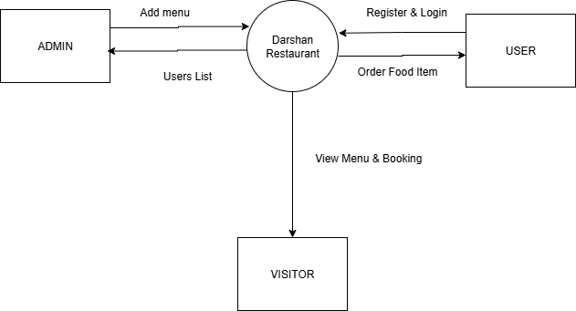

VISITOR

**1st Level Diagram :**

**Admin 1st Level Diagram:**

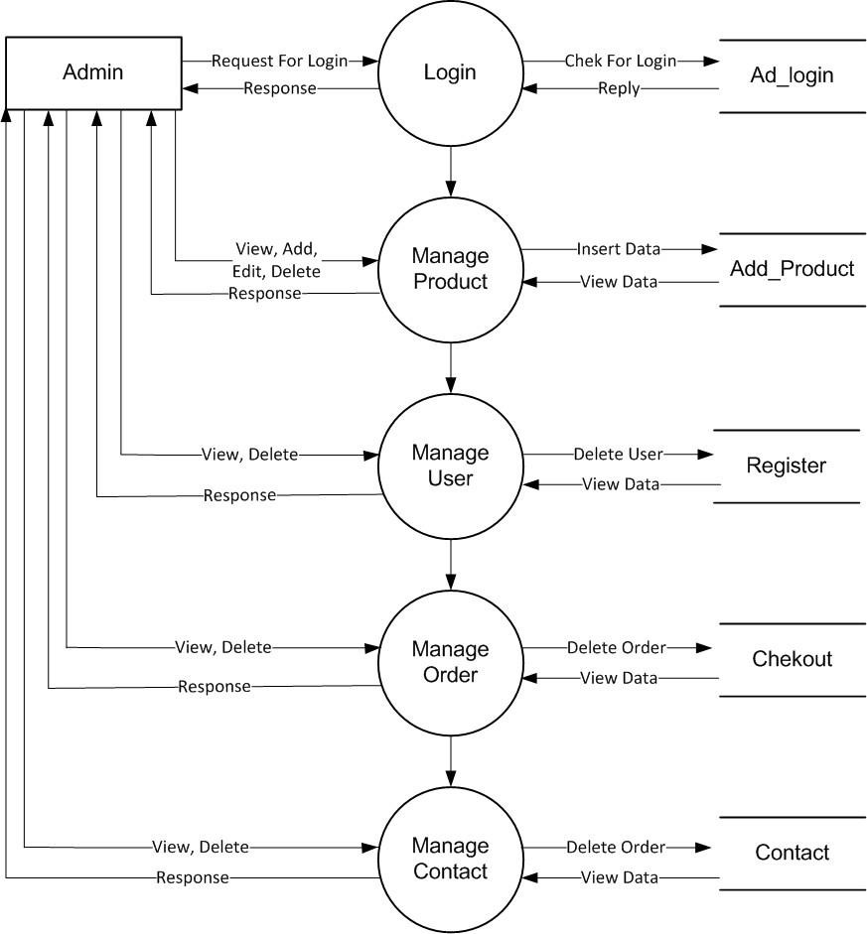

**User 1st Level Diagram:**

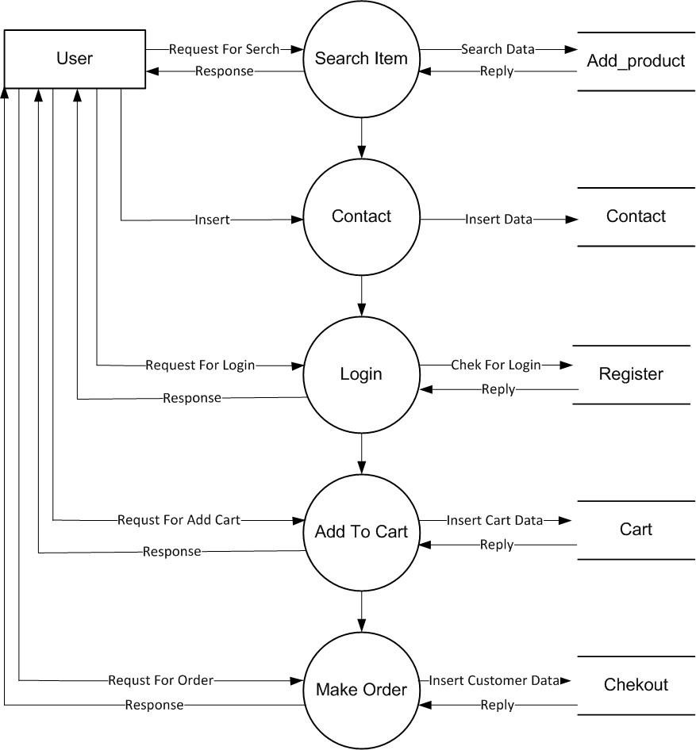

**Visitor 1st Level Diagram:**

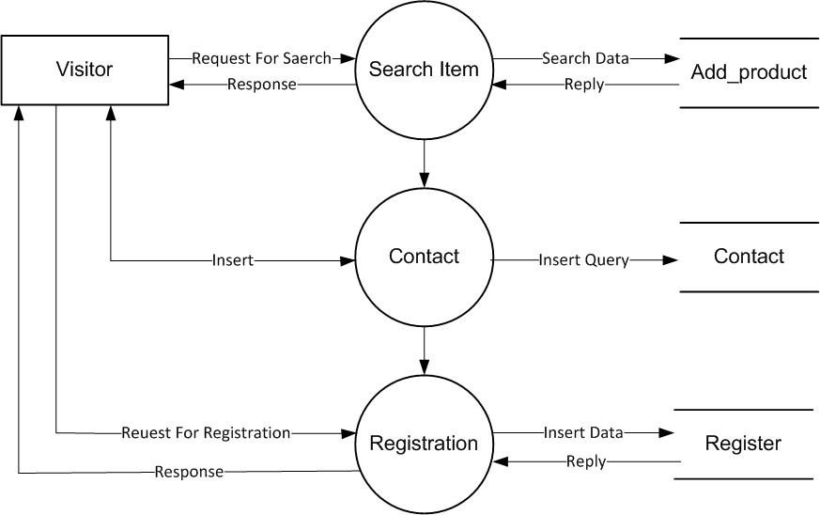

### 2nd Level Diagram :

**Admin 2nd Level Diagram :**

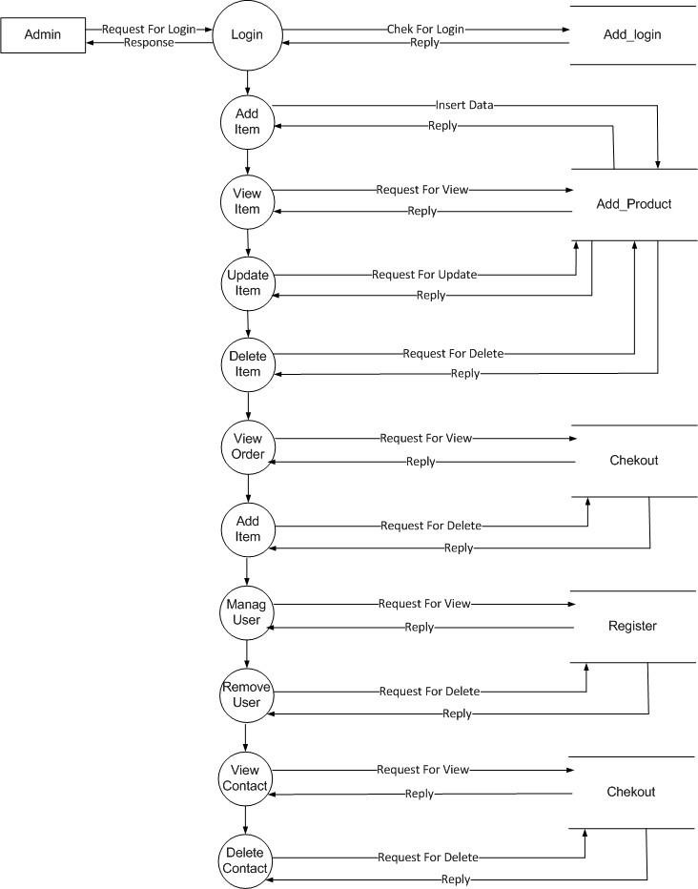

**User** 2nd **Level Diagram :**

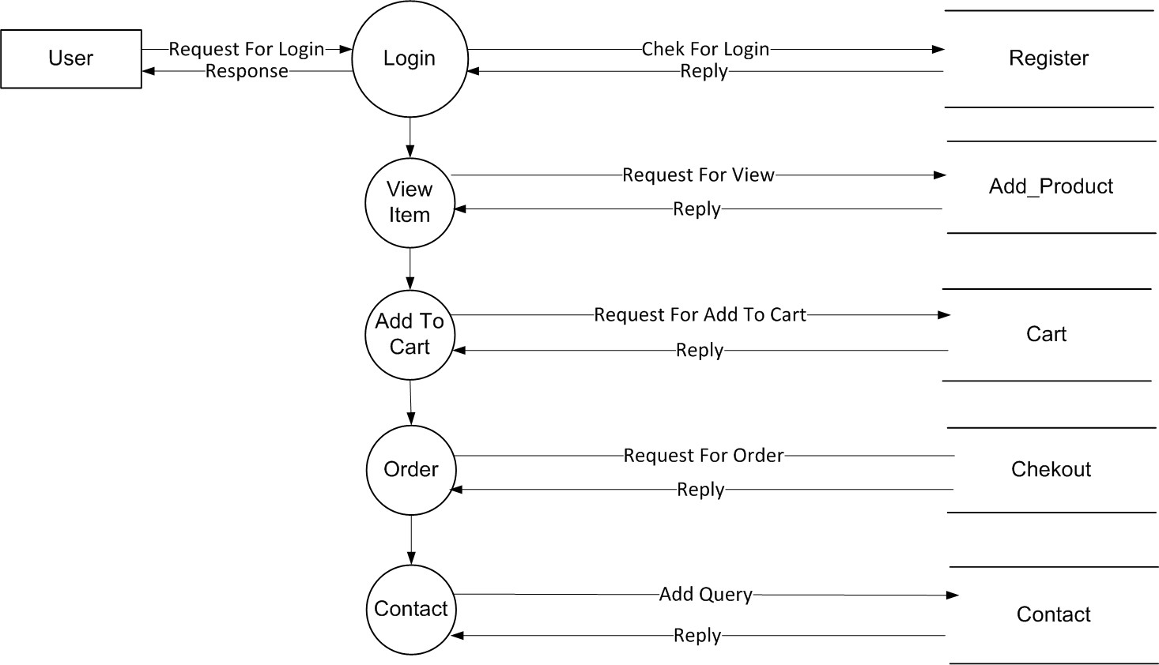

**Visitor 2nd Level Diagram :**

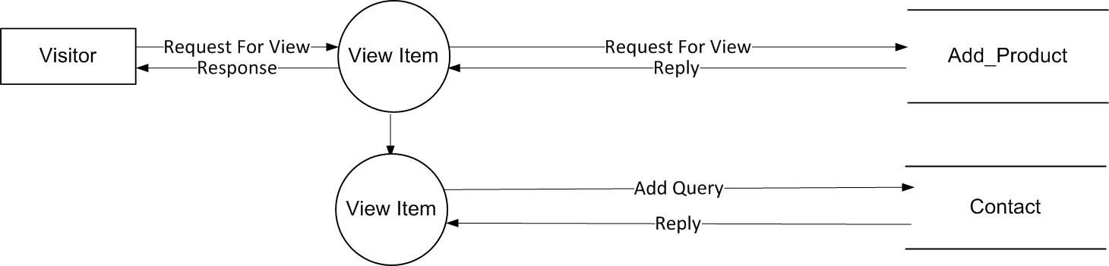

# USE CASE DIAGRAM

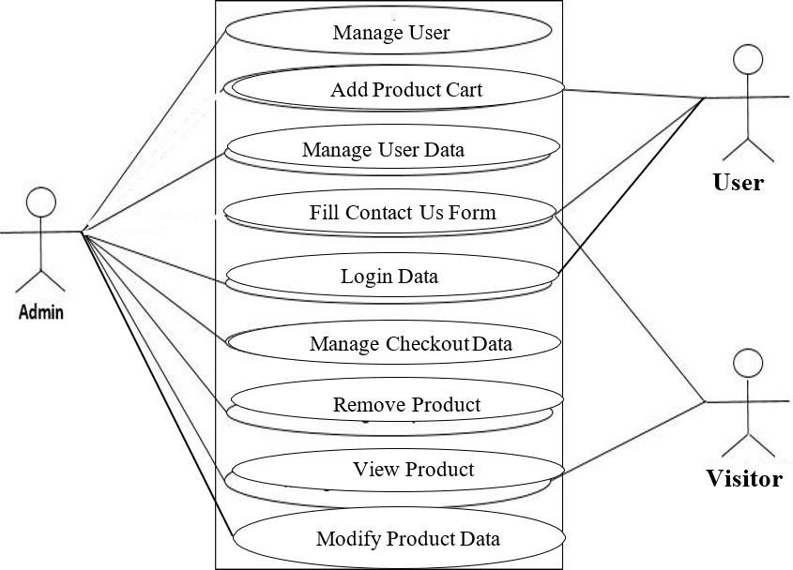

A use case is a set of scenarios that describing an interaction between a user and a system. A use case diagrams the relationship among actors and use cases. The two main components of a use case diagram are use cases and actors.

#### Actor Use Case

An actors is represents a user or another system that will interact with the system you are modeling. A use case is an external view of the system that represents some action the user might perform in order to complete a task.

Actor and use case description show the details description of interaction between the actor.

And their use case the description enables have a proper under standing of how actor interact.

# FLOW CHART

A Flow is a pictorial representation of an algorithm. Programmers often use it as a program-planning tool for visually organizing a sequence of steps necessary to solve a problem using computer. It uses boxes of different shapes to denote different type of instructions. The actual instructions are written within these boxes using clear and concise statements. Solid lines having arrow marks connect these boxes to indicate the flow of operation, that is, the exact sequence in which to execute the instructions. The process of drawing a flowchart for an algorithm is known as flowcharting.

### Basic Flowchart Symbols:

**Terminal Input/output**

**Processing Decision**

**Flow Lines Connectors**

**Administrative Login Flowchart:**

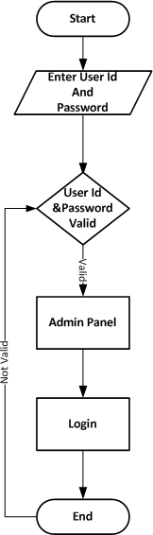

**General User Login Flowchart:**

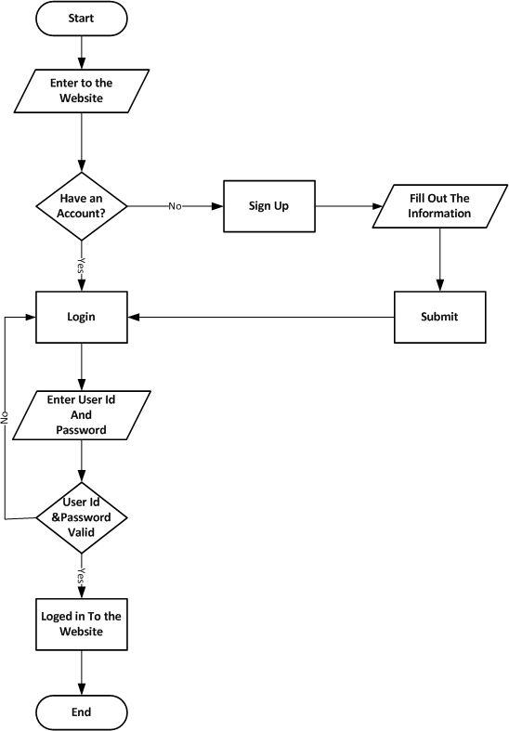

# COST ESTIMATION

In my project, I am implementing an Module Wise to calculate and evaluate the per-page average cost. This approach allows for a comprehensive assessment of cost allocation across various components, resulting in a more accurate and informative cost analysis.

### Module Wise:

Per-page 1000Rs Cost.

Total Price Of Pages

16*1000 = 16,000.00/-

#### Total = 16,000.00 /-

Thus, the approximation cost of this Web Site Project will be about Rs 16,000.00/-

# DATA DICTIONARY & NORMALIZATION

**Database Name:** darshanrestaurant

**Table 1**: users

|  |  |  |  |
| --- | --- | --- | --- |
| **Column Name** | **DataType (Size)** | **Constraints** | **Remarks** |
| id | Int(11) | A.I, P.K |  |
| email | Varchar(255) |  |  |
| password | Varchar(255) |  |  |
| user_type | Enum(“user”,”admin”) |  |  |
| created_at | timestamp |  |  |
| User_img | Varchar(255) |  |  |

**Table 2**: orders

|  |  |  |  |
| --- | --- | --- | --- |
| **Column Name** | **DataType (Size)** | **Constraints** | **Remarks** |
| Id | Int(11) | A.I, P.K |  |
| Menu_id | Int(10) |  |  |
| email | Varchar(255) |  |  |
| Menu_name | Varchar(255) |  |  |
| quantity | Int(11) |  |  |
| price | Int(10) |  |  |
| Total_price | Int(10) |  |  |
| mobile | Varchar(15) |  |  |
| address | text |  |  |
| status | enum('Confirmed', 'Shipping', 'Ongoing', 'Delivering’) |  |  |
| Order_time | timestamp |  |  |
| Order_date | date |  |  |
| Created_at | datetime |  |  |

**Table 3**: menu

|  |  |  |  |
| --- | --- | --- | --- |
| **Column Name** | **DataType (Size)** | **Constraints** | **Remarks** |
| Menu_id | int | A.I, P.K |  |
| Menu_name | Varchar(255) |  |  |
| Menu_description | text |  |  |
| menu_price | Int(10) |  |  |
| Menu_category | enum('starter', 'dinner', 'lunch', 'breakfast') |  |  |
| Menu_image | Varchar(255) |  |  |
| Created_at | timestamp |  |  |

**Table 4**: feedback

|  |  |  |  |
| --- | --- | --- | --- |
| **Column Name** | **DataType (Size)** | **Constraints** | **Remarks** |
| Feedback_Id | Int(11) | A.I, P.K |  |
| Feedback_name | Varchar(100) |  |  |
| Feedback_email | Varchar(100) |  |  |
| Feedback_rating | Int(11) |  |  |
| Feedback_message | text |  |  |
| Created_at | datetime |  |  |

**Table 5**: bookings

|  |  |  |  |
| --- | --- | --- | --- |
| **Column Name** | **DataType (Size)** | **Constraints** | **Remarks** |
| Id | Int(11) | A.I, P.K |  |
| Name | Varchar(100) |  |  |
| phone | Varchar(20) |  |  |
| Booking_time | time |  |  |
| Booking_date | date |  |  |
| email | Varchar(100) |  |  |
| people | Int(11) |  |  |
| message | text |  |  |
| Created_at | timestamp |  |  |
| status | Varchar(20) |  |  |

**Table 6**: gallery

|  |  |  |  |
| --- | --- | --- | --- |
| **Column Name** | **DataType (Size)** | **Constraints** | **Remarks** |
| Id | int |  |  |
| File_path | Varchar(255) |  |  |

# SCREEN LAYOUTS

### Client Side:

#### Index.php :

<img src="<?= $randomImage ?>" alt="User Image"

                                    style="width:60px; height:60px; border-radius:50%; object-fit:cover; margin-bottom: 10px; border: 2px solid #ffc107;">

                                <p class="text-center" style="flex-grow: 1; margin-bottom: 10px;">

                                    <i class="bi bi-quote quote-icon-left"></i>

                                    <?= $message ?>

                                    <i class="bi bi-quote quote-icon-right"></i>

                                </p>

                                <h3 class="mb-1">@<?= htmlspecialchars($username) ?></h3>

                                <div class="stars">

                                    <?php for ($i = 0; $i < $rating; $i++): ?>

                                        <i class="bi bi-star-fill text-warning"></i>

                                    <?php endfor; ?>

                                </div>

#### Index.php( book a table) :

// Use prepared statements for security

$stmt = $conn->prepare("INSERT INTO bookings (name, email, phone, booking_date,

booking_time, people, message) VALUES (?, ?, ?, ?, ?, ?, ?)");

$stmt->bind_param("sssssis", $name, $email, $phone, $date, $time, $people, $message);

if ($stmt->execute()) {

$_SESSION['msg'] = ['type' => 'success', 'text' => 'Your table has been booked!'];

} else {

$_SESSION['msg'] = ['type' => 'error', 'text' => 'Booking failed: ' . $stmt->error];

}

#### Menu.php :

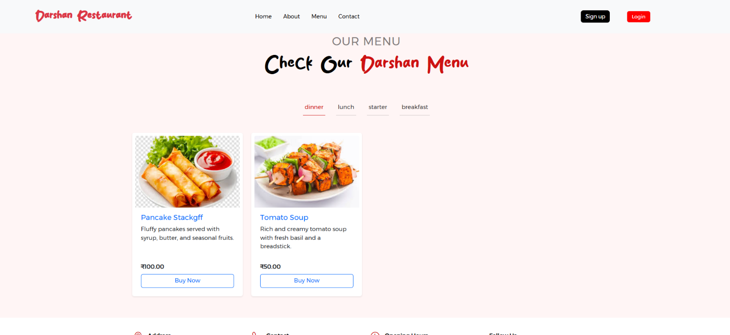

$catSql = "SELECT DISTINCT menu_category FROM menu";

$catResult = $conn->query($catSql);

$foundCategories = [];

if ($catResult->num_rows > 0) {

    while ($cat = $catResult->fetch_assoc()) {

        $foundCategories[] = $cat['menu_category'];

    }

}

#### Contactus.php :

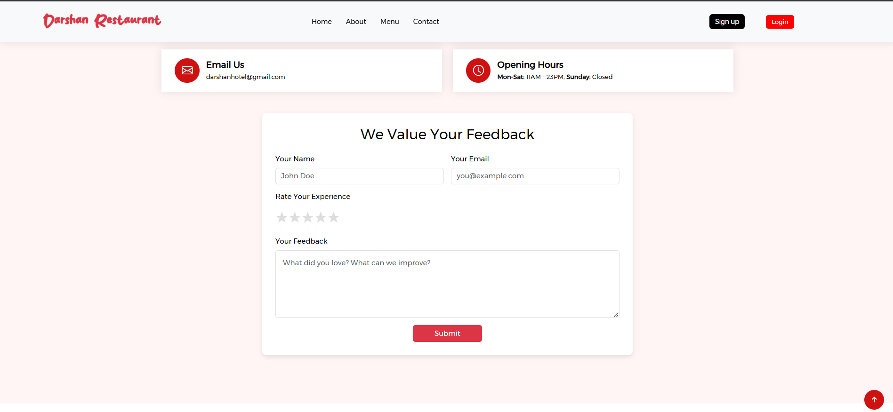

$stmt = $conn->prepare("INSERT INTO feedback (feedback_name, feedback_email,

feedback_rating, feedback_message) VALUES (?, ?, ?, ?)");

    if ($stmt) {

        $stmt->bind_param("ssis", $name, $email, $rating, $message);

        if ($stmt->execute()) {

            $_SESSION['alert'] = [

                'status' => 'success',

                'msg' => 'Thank you for your feedback!'

            ];

        }

#### Myorder.php (client side logined):

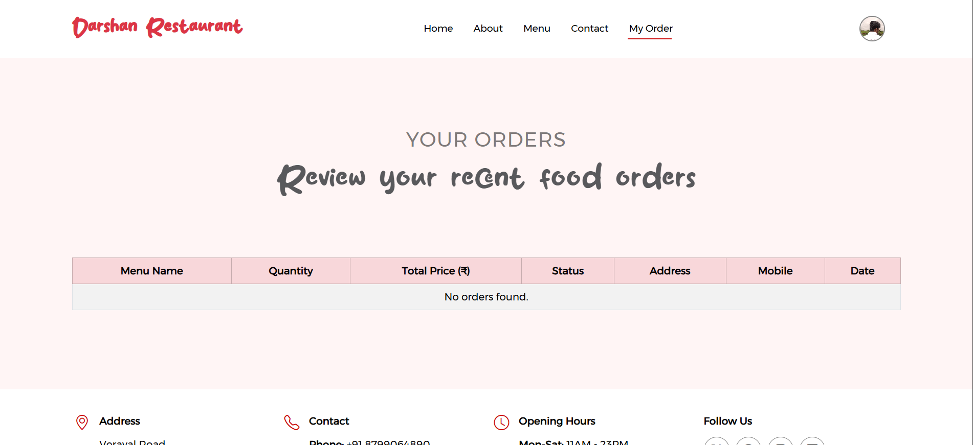

$sql = "SELECT menu_name, quantity, total_price, status, address, mobile, order_date

        FROM orders

        WHERE email = ?

        ORDER BY order_date DESC";

$stmt = $conn->prepare($sql);

if (!$stmt) {

    die("SQL prepare failed: " . $conn->error);

}

$stmt->bind_param("s", $email);

$stmt->execute();

$result = $stmt->get_result();

#### Menu.php(order menu in bootstrap model) :

$stmt = $conn->prepare("INSERT INTO orders (email, menu_id, menu_name, quantity, price, total_price, mobile, address) VALUES (?, ?, ?, ?, ?, ?, ?, ?)");

    $stmt->bind_param("sisisdss", $email, $menu_id, $menu_name, $quantity, $price, $total_price, $mobile, $address);

    if ($stmt->execute()) {

        $_SESSION['order_status'] = ['status' => 'success', 'message' => 'Your order has been placed successfully!'];

    }

#### Admin side Gallery Image upload :

if (

        move_uploaded_file($file, $targetFile) &&

        $conn->query("INSERT INTO gallery (file_path) VALUES ('$targetFile')")

    ) {

        $_SESSION['msg'] = ['type' => 'success', 'text' => 'Image uploaded successfully!'];

        header("Location: /college/admin/index");

        exit();

    }

#### Admin side menu.php (CRUD menu food items):

$catSql = "SELECT DISTINCT menu_category FROM menu";

$catResult = $conn->query($catSql);

$categories = [];

if ($catResult && $catResult->num_rows > 0) {

    while ($cat = $catResult->fetch_assoc()) {

        $categories[] = $cat['menu_category'];

    }

}

#### Admin side (admin user add) :

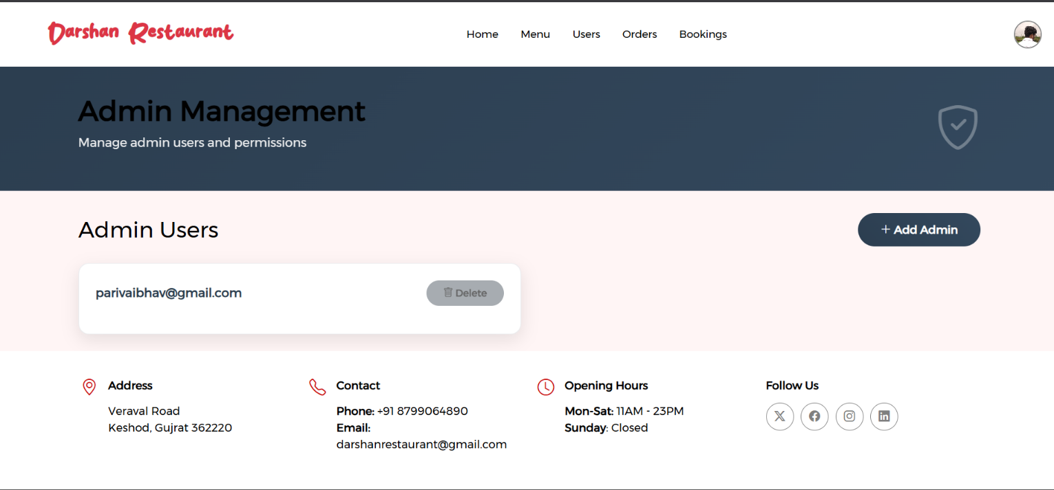

$stmt = $conn->prepare("INSERT INTO users (email, password, user_type)

VALUES (?, ?, 'admin')");

    $stmt->bind_param("ss", $email, $password);

    if ($stmt->execute()) {

        $_SESSION['msg'] = ['type' => 'success', 'text' => 'Admin added successfully!'];

    }

#### Admin side myorders.php (order management):

switch ($filter) {

    case 'today':

        $whereClause = "WHERE DATE(created_at) = CURDATE()";

        break;

    case 'last_week':

        $whereClause = "WHERE created_at >= DATE_SUB(CURDATE(), INTERVAL 7 DAY)";

        break;

    case 'last_month':

        $whereClause = "WHERE created_at >= DATE_SUB(CURDATE(), INTERVAL 1 MONTH)";

        break;

    case 'last_year':

        $whereClause = "WHERE created_at >= DATE_SUB(CURDATE(), INTERVAL 1 YEAR)";

        break;

}

$sql = "SELECT order_id, email, menu_name, quantity, mobile, address, status FROM orders $whereClause ORDER BY order_id DESC";

$result = $conn->query($sql);

#### Bookings.php :

$filter = $_GET['filter'] ?? '';

$whereClause = '';

$dateToday = date('Y-m-d');

switch ($filter) {

    case 'today':

        $whereClause = "WHERE booking_date = '$dateToday'";

        break;

    case 'last_week':

        $lastWeek = date('Y-m-d', strtotime('-7 days'));

        $whereClause = "WHERE booking_date BETWEEN '$lastWeek' AND '$dateToday'";

        break;

    case 'last_month':

        $lastMonth = date('Y-m-d', strtotime('-1 month'));

        $whereClause = "WHERE booking_date BETWEEN '$lastMonth' AND '$dateToday'";

        break;

    case 'last_year':

        $lastYear = date('Y-m-d', strtotime('-1 year'));

        $whereClause = "WHERE booking_date BETWEEN '$lastYear' AND '$dateToday'";

        break;

}

**Register.php:**

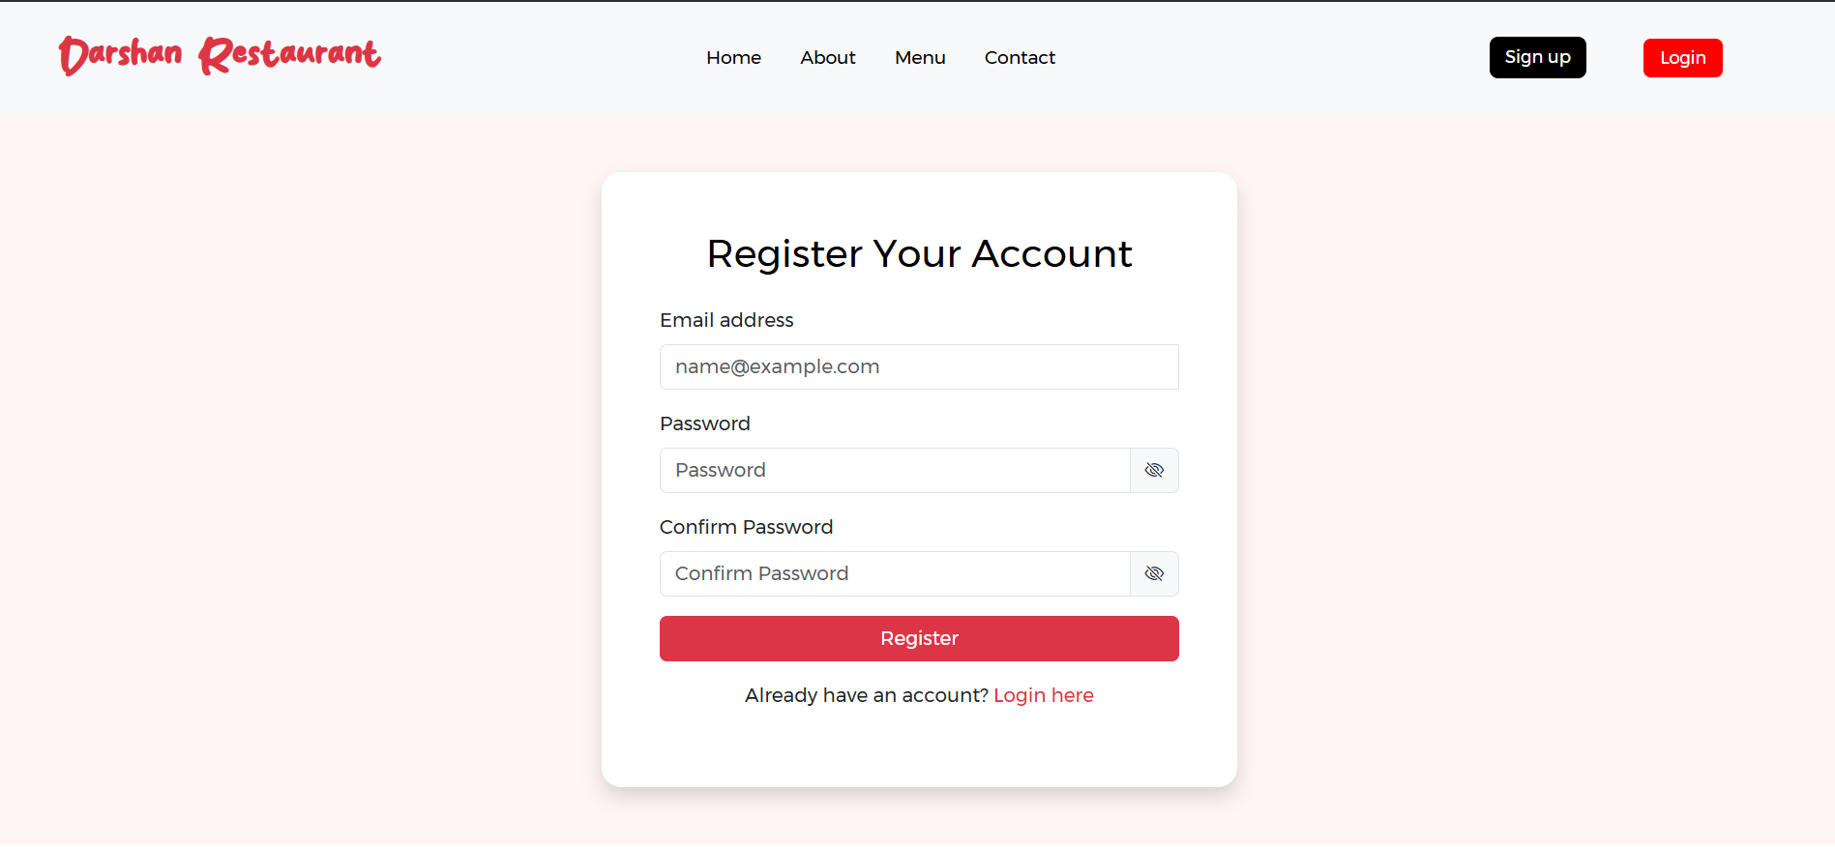

$insert = $conn->prepare(

    'INSERT INTO users (email, password, user_type) VALUES (?, ?, ?)'

);

$insert->bind_param('sss', $email, $passwordHash, $userType);

if (!$insert->execute()) {

    error_log('Signup error: ' . $insert->error);

    $_SESSION['msg'] = ['type' => 'error', 'text' => 'Registration failed.'];

    $insert->close();

    header('Location: /college/register');

    exit();

}

$insert->close();

/* --------- success: set session & cookies --------- */

$_SESSION['msg'] = ['type' => 'success', 'text' => 'Registration successful!'];

#### Login.php:

$stmt = $conn->prepare('SELECT email, password, user_type FROM users WHERE email = ? LIMIT 1');

/*  Verify credentials  */

if (!$user || !password_verify($password, $user['password'])) {

    $_SESSION['msg'] = ['type' => 'error', 'text' => 'Invalid credentials'];

    header('Location: /college/login');

    exit();

}

$_SESSION['msg'] = ['type' => 'success', 'text' => 'Lo

# SPECIAL UTILITIES

Following are special utilities provided by Shivam Mobile.

* Attractive layout provides to user.
* Easy to find category wise data
* Provides better way to get menu information.
* Everyone can free register for his/her sign in.
* Easy to check out product
* Any Query to fill a contact form
* A map has also been provided if the customer wants to come to the restaurant

# TESTING

Software Development Life Cycle (SDLC) includes a series of production activities one of this is testing.

Testing is a process of executing a program with the intent of finding an error.

Testing is the most important element to be considered for providing quality software and it represents the ultimate review of specification, design and coding.

The success or failure of the software as a system mainly depends on testing.

Software Developer spends 40% to 50% of their total development time on testing.

There are several SDLC techniques and development model. I have focused on Prototype Model. I have followed the prototyping model to develop this Software.

The development of software system involves a series of production activities where opportunities for injection of human fallibility are enormous. Error may begin to occur at the very inception of the process where the objectives may be erroneously or imperfectly specified, as well as later design and development states. Because of human inability to perform and communicate with perfection, software development is accompanied by a quality assurance activity.

Testing is program consists of providing the program with a set of test inputs and observing if the programs behave as expected. Under which a failure occurs are noted for debugging and correction. The following are some commonly used terms associated with testing.

A failure is manifestation of an error. But, the mere presence of an error may not necessarily lead to a failure.

A fault is an incorrect intermediate state that may have been entered during program execution. A fault may or may not lead to a failure.

A test case is the triplet [I.S.O.], where I is the data input to the system, S is the state of the system at which the data is input, and O is the expected output of the system.

A test suite is the set of all test cases with which a given software product is to be tested.

Many types of testing techniques are describing as follows.

### Unit Testing:

Unit testing is under taken when a module has been coded and successfully reviewed in this section we first discuss the environment needed to perform unit testing.

Here in this project we test each and every module and forms of software application individually when it is completely coded.

There are some methods for unit testing are as follows.

### Black-Box Testing:

* Equivalence Class Partitioning
* Boundary Value Analysis

### White-Box Testing:

* Statement coverage
* Branch Coverage
* Condition Coverage
* Path Coverage
* Linearly independent Path
* Data Flow - Based Testing
* Mutation testing

### Integration Testing:

The primary objectives of the integration testing is to test the module interface in order to ensure that there are no error in parameter passing when one module invokes another module.

During integration testing different module of system as per integration plane the integration plan specify the steps and the order in which module are combine to realize the full system.

After each integration test the practical integrated system is tested. Following are the integration testing Methods & Approaches

* Big bang approach
* Top down approach
* Bottom up approach
* Mixed approach

### System Testing:

In the system testing the whole application is tested and the error and failure possibility is carried out in it.

Following are the method & approach of system testing.

* Alpha testing
* Beta testing
* Acceptance testing
* Performance testing
* Error seeding

Testing is a process of executing a program with the intent of finding an error.

A good test case is one that as a high probability of finding an as yet in discovered error.

A successful test is one that uncovers a yet undiscovered error.

Software testing is a critical element of software quality assurance and represents the ultimate review of specification, design and coding. the increasing visibility of software as a system element and the attendant “Cost” associated with a software failure are motivating forces for well – planned, thorough testing. It is not unusual for a software development organization to expend between 30 to 40 percent of total project effort on testing. In the extreme, testing of human-rated software can cost three to five times as much as all other software engineering activities combined.

# Test Case

## VALIDATION CHECKS TEST CASES:

A Test case is a set of conditions or variable under which a tester will determine whether a system satisfy requirement or works correctly.

The process of developing test case can also help to find the problem in requirement or design of an application.

A test case can have the following elements, not however that normally a test management tool is used by companies by the tool used.

**Test Suit ID :** The ID of the test suit, to which this test case belongs.

**Test Case ID :** The ID of the test case.

**Expected Result :** The expected result of the test. Actual Result: The actual result of the test, to filled after executing the test case.

**Created By :** The name of the author of the test case.

**Executed By :** The name of the person who executing the test cases.

**Pass/Fail :** The result in "Pass" or "Fail" according to the test, when the expected result and the actual result is same then the result is "pass" else result is "fail".

**Remark :** Any comment on the test case or test execution.

I create following some test cases which is executed by me.

|  |  |  |  |  |  |
| --- | --- | --- | --- | --- | --- |
| Test Suite ID : 1 Test Case ID : 1  Created By : Pari Vaibhavpari b. Executed By :Pari Vaibhavpari b.  Executed Date : 05 Sep 2023 | | | Description :  This test case will checks the validation functionality on the login form. | | |
| Task no | Task | Expected Result | Actual Result | Pass / Fail | Remark |
| 1 | Enter valid  username and password | Login Successfully | Login Success | Pass |  |
| 2 | Enter Invalid username password | Login failed, Error Occurred | Generating an error message | Pass |  |
| 3 | Click on login button without  providing any value | An error  message will generate | Generating an error message | Pass |  |

|  |  |  |  |  |  |
| --- | --- | --- | --- | --- | --- |
| Test Suite ID : 1 Test Case ID : 1  Created By : Pari Vaibhavpari  Executed By: Pari Vaibhavpari  Executed Date : 05 Sep 2025 | | | Description :  This test case will check the validation functionality on the signup form. | | |
| Task no. | Task. | Task no. | Actual Result | Pass/ Fail | Remark |
| 1 | Enter valid username and  password | 1 | Allow to username &  password | Pass |  |
| 2 | Enter Invalid username and  password | 2 | Generating an error message | Pass |  |
| 3 | Click on Signup button without  providing any value | 3 | Generating an error message | Pass |  |
| 4 | Enter less than 4 character in  password field. | 4 | Actual Result | Pass/ Fail | Remark |

# IMPLEMENTATION

Implementation refers to the entire effort associated with a new system. The implementation of a web application involves longer term issues after the system has been designed and installed. Implementation is a part of the design of a web application, and is an organizational change process. It is a part of the process that begins with the very first idea for a web application has been successfully integrated with the operations of the organization. We expect most of the implementation to be concerned with behavioral phenomena since people are expected to change their information processing activities.

The implementation is processed from review and reports from developer cover the following areas:

* Good working conditions.
* Useful for gathering information.
* Update website easily.
* Attractive layouts.
* Working for as per requirements.

# BIBLIOGRAPHY

### Websites used:

* [www.microsoft.com](http://www.microsoft.com/)
* [www.w3c.org](http://www.w3c.org/)
* [www.google.com](http://www.google.com/)
* [www.wikipedia.org](http://www.wikipedia.org/)
* [chat.openai.com](http://www.flipkart.com/)